1. Susikuriam folderi kur saugosim projekto failus
2. nueinu i direktorija kuria sukuriau cd "Folderis/kuri/sukuriau";
3. paleidziu is terminalo komanda: composer create-project --prefer-dist laravel/laravel cars
4. susikuriu duomenu baze
5. susivedu duomenu bazes prisijungimus i .env failiuka IR
config/database.php
6. susikuriame duombazes migracija: php artisan make:migration create_cars_table
7. aprasau reikalingus stulpelius migracijoje
8. paleidziu migracija: php artisan migrate
9. Sukuriu Car modeli: php artisan make:model Car
10. app/Car.php pridedu: protected $table = "cars";
11. Sukuriu controlleri masinu: php artisan make:controller CarsController --resource
12. Sukuriu route'a routes/web.php faile.
13. Aprasau masinu atvaizdavimo funkcija controlleryje (pvz: index)
14. Jei noriu naudoti Car modeli controlleryje, reikia virsuje parasyti: use App\Car;
15. Atavaizdavimo funkcijoje pasiemu visu auto duomenis ir nusiunciu i view.
16. Susikuriu view faila resources/views/cars.blade.php
17. view faile aprasau masinu atvaidavima (pageidautina graziai)
18. Sukurti repozitorija ir pasidalinti su destyoju ir draugais

Noredami kazka istrinti:
1. Sukuriam route'a POST metodu routes/web.php faile. Pvz Route::post('/comments/{id}/delete', 'CommentsController@destroy')->name('delete')
2. Duomenu sarase susikuriam prie norimo istrinti elemento forma su action {{ route('delete') }} ir method="POST" butinai pridedame formos viduje {{ csrf_field() }}
3. tada keliaujame i controllerio funkcija kuri bus vykdoma istrynimo metu
4. Funkcijoi gauname parametra ID, gauname elementa paga id: Comment::find($id);
5. istriname pasirinka modelio objekta su $comment->delete();
6. Atvaizdavimo jokio nedarome trynimo metu
7. Graziname (return) return redirect()->route('comments.index');

Kodo pvz:
https://bitbucket.org/eimkasp/bta-laravel/commits/c3fb47e7a2ee1f91e9b732c101b8821924f76c9d

Sukonfiguruoti visa pasijungima automatiskai komandineje eiluteje
php artisan config:clear
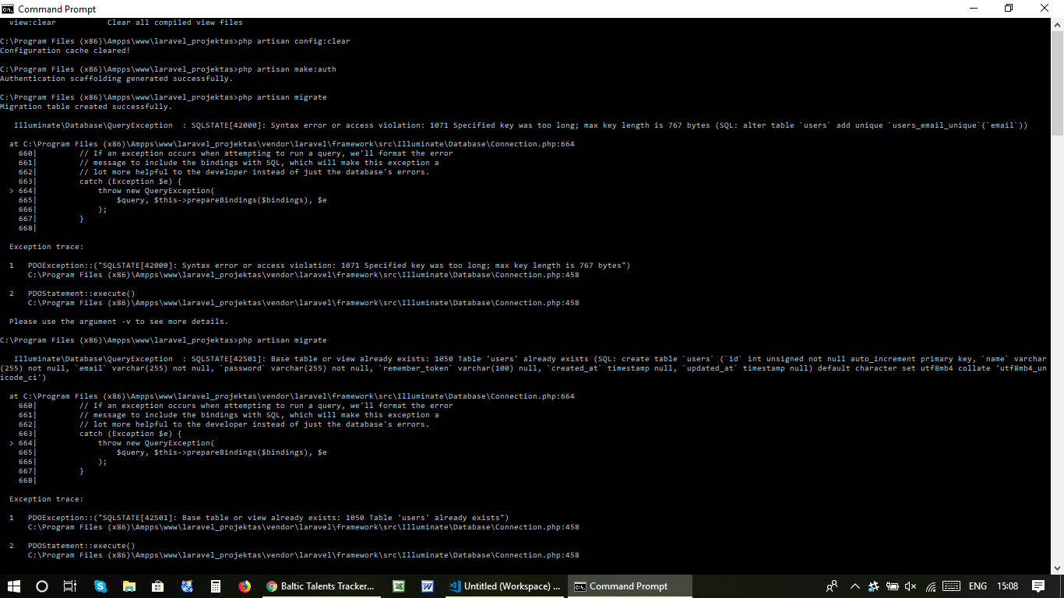

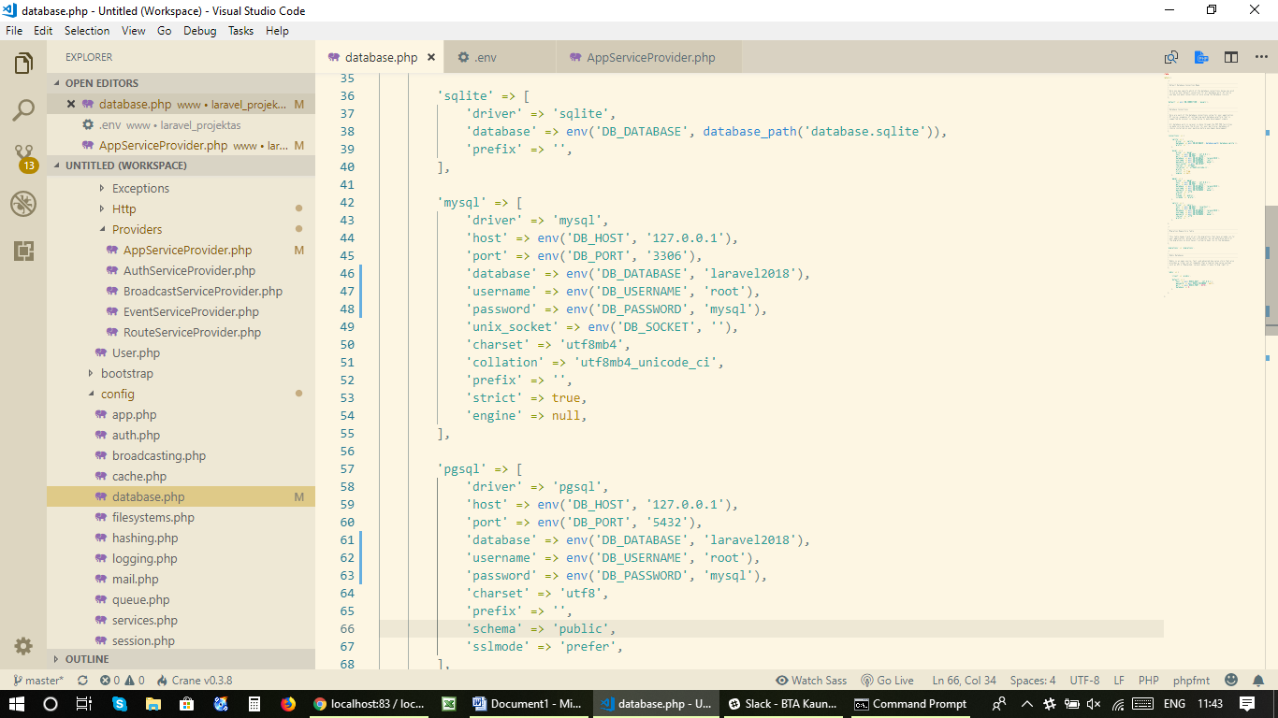

Sukurimas lenteliu duomenu bazeje
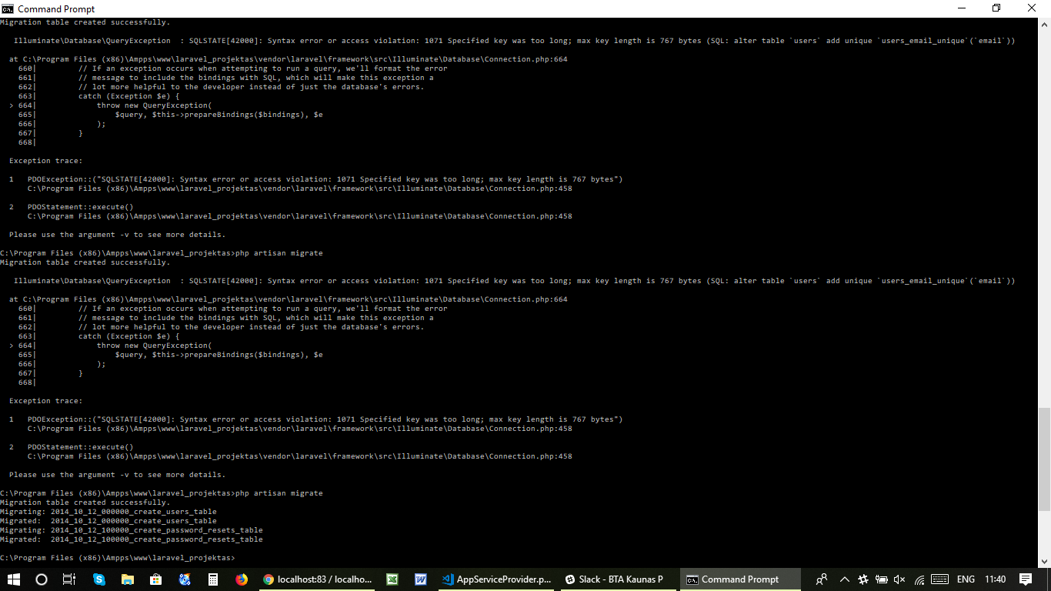

Irasyti situos
Schema::defaultStringLength(191); use Illuminate\Support\Facades\Schema;
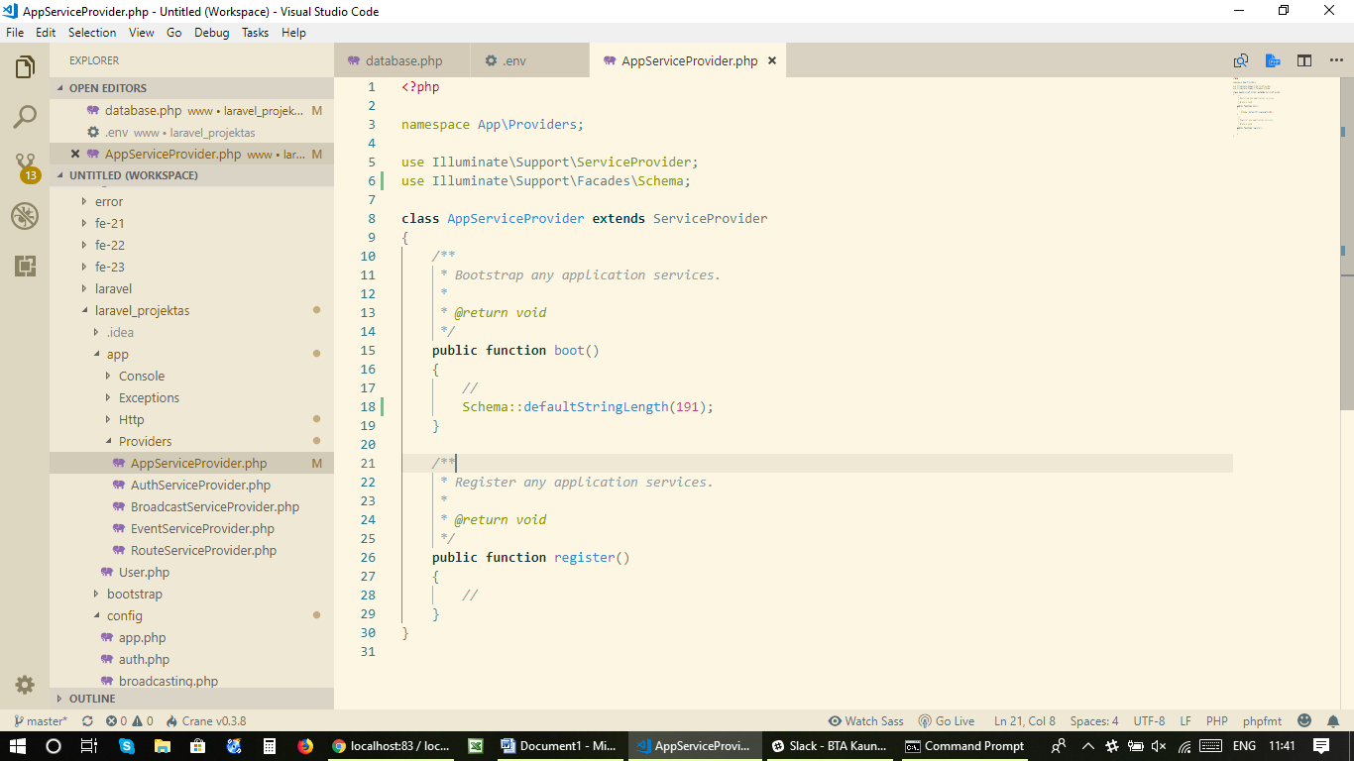

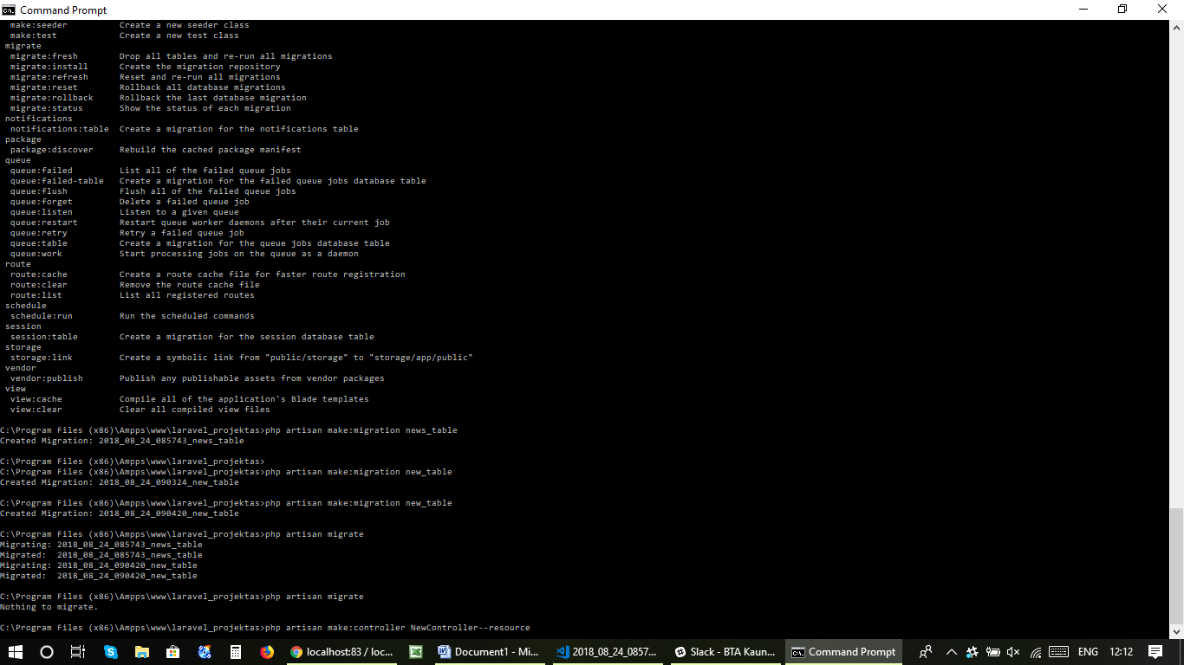

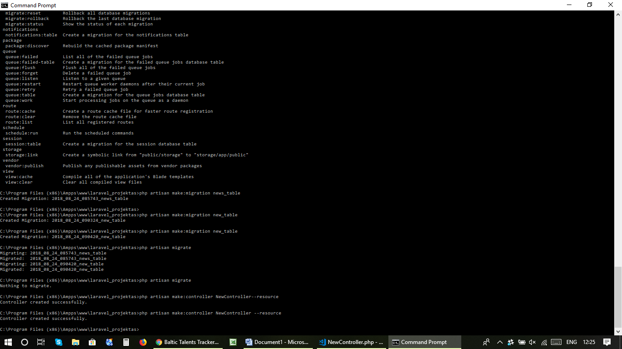

Modelio kurimas
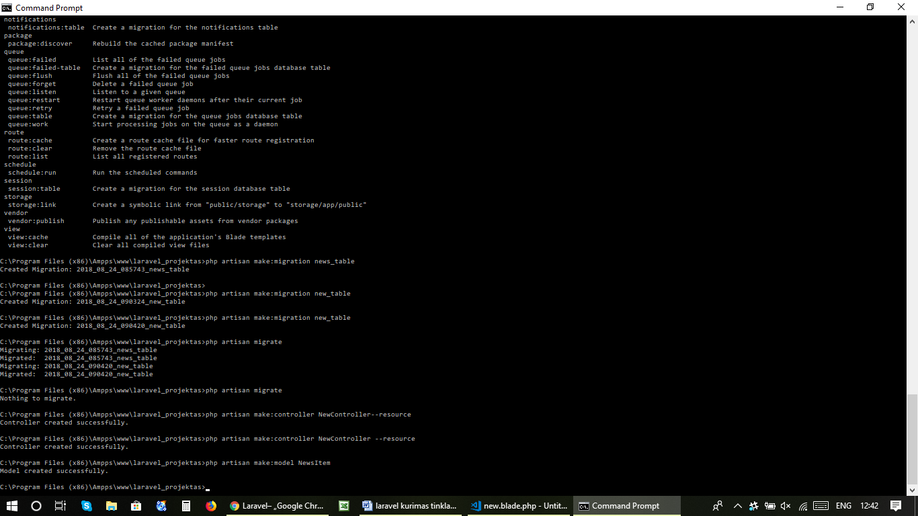

Iterpti dar viena stilpeli I eilute:
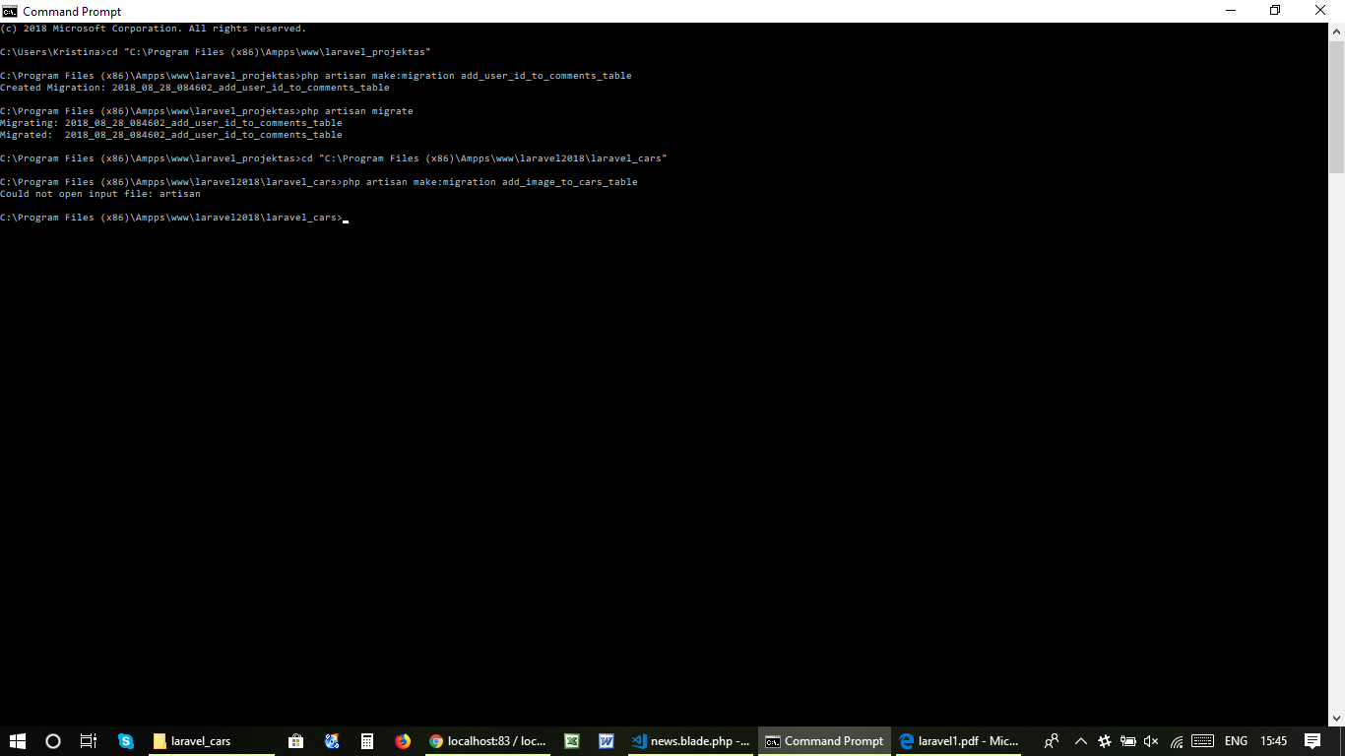
Komandine eilute☺

schedule
schedule:run Run the scheduled commands
session
session:table Create a migration for the session database table
storage
storage:link Create a symbolic link from "public/storage" to "storage/app/public"
vendor
vendor:publish Publish any publishable assets from vendor packages
view
view:cache Compile all of the application's Blade templates
view:clear Clear all compiled view files

C:\Program Files (x86)\Ampps\www\laravel_projektas>php artisan config:clear
Configuration cache cleared!

C:\Program Files (x86)\Ampps\www\laravel_projektas>php artisan make:auth
Authentication scaffolding generated successfully.

C:\Program Files (x86)\Ampps\www\laravel_projektas>php artisan migrate
Migration table created successfully.

Illuminate\Database\QueryException : SQLSTATE[42000]: Syntax error or access violation: 1071 Specified key was too long; max key length is 767 bytes (SQL: alter table `users` add unique `users_email_unique`(`email`))

at C:\Program Files (x86)\Ampps\www\laravel_projektas\vendor\laravel\framework\src\Illuminate\Database\Connection.php:664
660| // If an exception occurs when attempting to run a query, we'll format the error
661| // message to include the bindings with SQL, which will make this exception a
662| // lot more helpful to the developer instead of just the database's errors.
663| catch (Exception $e) {
> 664| throw new QueryException(
665| $query, $this->prepareBindings($bindings), $e
666| );
667| }
668|

Exception trace:

1 PDOException::("SQLSTATE[42000]: Syntax error or access violation: 1071 Specified key was too long; max key length is 767 bytes")
C:\Program Files (x86)\Ampps\www\laravel_projektas\vendor\laravel\framework\src\Illuminate\Database\Connection.php:458

2 PDOStatement::execute()
C:\Program Files (x86)\Ampps\www\laravel_projektas\vendor\laravel\framework\src\Illuminate\Database\Connection.php:458

Please use the argument -v to see more details.

C:\Program Files (x86)\Ampps\www\laravel_projektas>php artisan migrate

Illuminate\Database\QueryException : SQLSTATE[42S01]: Base table or view already exists: 1050 Table 'users' already exists (SQL: create table `users` (`id` int unsigned not null auto_increment primary key, `name` varchar(255) not null, `email` varchar(255) not null, `password` varchar(255) not null, `remember_token` varchar(100) null, `created_at` timestamp null, `updated_at` timestamp null) default character set utf8mb4 collate 'utf8mb4_unicode_ci')

at C:\Program Files (x86)\Ampps\www\laravel_projektas\vendor\laravel\framework\src\Illuminate\Database\Connection.php:664
660| // If an exception occurs when attempting to run a query, we'll format the error
661| // message to include the bindings with SQL, which will make this exception a
662| // lot more helpful to the developer instead of just the database's errors.
663| catch (Exception $e) {
> 664| throw new QueryException(
665| $query, $this->prepareBindings($bindings), $e
666| );
667| }
668|

Exception trace:

1 PDOException::("SQLSTATE[42S01]: Base table or view already exists: 1050 Table 'users' already exists")
C:\Program Files (x86)\Ampps\www\laravel_projektas\vendor\laravel\framework\src\Illuminate\Database\Connection.php:458

2 PDOStatement::execute()
C:\Program Files (x86)\Ampps\www\laravel_projektas\vendor\laravel\framework\src\Illuminate\Database\Connection.php:458

Please use the argument -v to see more details.

C:\Program Files (x86)\Ampps\www\laravel_projektas>php artisan migrate
Migration table created successfully.

Illuminate\Database\QueryException : SQLSTATE[42000]: Syntax error or access violation: 1071 Specified key was too long; max key length is 767 bytes (SQL: alter table `users` add unique `users_email_unique`(`email`))

at C:\Program Files (x86)\Ampps\www\laravel_projektas\vendor\laravel\framework\src\Illuminate\Database\Connection.php:664
660| // If an exception occurs when attempting to run a query, we'll format the error
661| // message to include the bindings with SQL, which will make this exception a
662| // lot more helpful to the developer instead of just the database's errors.
663| catch (Exception $e) {
> 664| throw new QueryException(
665| $query, $this->prepareBindings($bindings), $e
666| );
667| }
668|

Exception trace:

1 PDOException::("SQLSTATE[42000]: Syntax error or access violation: 1071 Specified key was too long; max key length is 767 bytes")
C:\Program Files (x86)\Ampps\www\laravel_projektas\vendor\laravel\framework\src\Illuminate\Database\Connection.php:458

2 PDOStatement::execute()
C:\Program Files (x86)\Ampps\www\laravel_projektas\vendor\laravel\framework\src\Illuminate\Database\Connection.php:458

Please use the argument -v to see more details.

C:\Program Files (x86)\Ampps\www\laravel_projektas>php artisan migrate
Migration table created successfully.

Illuminate\Database\QueryException : SQLSTATE[42000]: Syntax error or access violation: 1071 Specified key was too long; max key length is 767 bytes (SQL: alter table `users` add unique `users_email_unique`(`email`))

at C:\Program Files (x86)\Ampps\www\laravel_projektas\vendor\laravel\framework\src\Illuminate\Database\Connection.php:664
660| // If an exception occurs when attempting to run a query, we'll format the error
661| // message to include the bindings with SQL, which will make this exception a
662| // lot more helpful to the developer instead of just the database's errors.
663| catch (Exception $e) {
> 664| throw new QueryException(
665| $query, $this->prepareBindings($bindings), $e
666| );
667| }
668|

Exception trace:

1 PDOException::("SQLSTATE[42000]: Syntax error or access violation: 1071 Specified key was too long; max key length is 767 bytes")
C:\Program Files (x86)\Ampps\www\laravel_projektas\vendor\laravel\framework\src\Illuminate\Database\Connection.php:458

2 PDOStatement::execute()
C:\Program Files (x86)\Ampps\www\laravel_projektas\vendor\laravel\framework\src\Illuminate\Database\Connection.php:458

Please use the argument -v to see more details.

C:\Program Files (x86)\Ampps\www\laravel_projektas>php artisan migrate
Migration table created successfully.

Illuminate\Database\QueryException : SQLSTATE[42000]: Syntax error or access violation: 1071 Specified key was too long; max key length is 767 bytes (SQL: alter table `users` add unique `users_email_unique`(`email`))

at C:\Program Files (x86)\Ampps\www\laravel_projektas\vendor\laravel\framework\src\Illuminate\Database\Connection.php:664
660| // If an exception occurs when attempting to run a query, we'll format the error
661| // message to include the bindings with SQL, which will make this exception a
662| // lot more helpful to the developer instead of just the database's errors.
663| catch (Exception $e) {
> 664| throw new QueryException(
665| $query, $this->prepareBindings($bindings), $e
666| );
667| }
668|

Exception trace:

1 PDOException::("SQLSTATE[42000]: Syntax error or access violation: 1071 Specified key was too long; max key length is 767 bytes")
C:\Program Files (x86)\Ampps\www\laravel_projektas\vendor\laravel\framework\src\Illuminate\Database\Connection.php:458

2 PDOStatement::execute()
C:\Program Files (x86)\Ampps\www\laravel_projektas\vendor\laravel\framework\src\Illuminate\Database\Connection.php:458

Please use the argument -v to see more details.

C:\Program Files (x86)\Ampps\www\laravel_projektas>php artisan migrate
Migration table created successfully.
Migrating: 2014_10_12_000000_create_users_table
Migrated: 2014_10_12_000000_create_users_table
Migrating: 2014_10_12_100000_create_password_resets_table
Migrated: 2014_10_12_100000_create_password_resets_table

C:\Program Files (x86)\Ampps\www\laravel_projektas>php artisan
Laravel Framework 5.6.34

Usage:
command [options] [arguments]

Options:
-h, --help Display this help message
-q, --quiet Do not output any message
-V, --version Display this application version
--ansi Force ANSI output
--no-ansi Disable ANSI output
-n, --no-interaction Do not ask any interactive question
--env[=ENV] The environment the command should run under
-v|vv|vvv, --verbose Increase the verbosity of messages: 1 for normal output, 2 for more verbose output and 3 for debug

Available commands:
clear-compiled Remove the compiled class file
down Put the application into maintenance mode
env Display the current framework environment
help Displays help for a command
inspire Display an inspiring quote
list Lists commands
migrate Run the database migrations
preset Swap the front-end scaffolding for the application
serve Serve the application on the PHP development server
tinker Interact with your application
up Bring the application out of maintenance mode
app
app:name Set the application namespace
auth
auth:clear-resets Flush expired password reset tokens
cache
cache:clear Flush the application cache
cache:forget Remove an item from the cache
cache:table Create a migration for the cache database table
config
config:cache Create a cache file for faster configuration loading
config:clear Remove the configuration cache file
db
db:seed Seed the database with records
event
event:generate Generate the missing events and listeners based on registration
key
key:generate Set the application key
make
make:auth Scaffold basic login and registration views and routes
make:channel Create a new channel class
make:command Create a new Artisan command
make:controller Create a new controller class
make:event Create a new event class
make:exception Create a new custom exception class
make:factory Create a new model factory
make:job Create a new job class
make:listener Create a new event listener class
make:mail Create a new email class
make:middleware Create a new middleware class
make:migration Create a new migration file
make:model Create a new Eloquent model class
make:notification Create a new notification class
make:observer Create a new observer class
make:policy Create a new policy class
make:provider Create a new service provider class
make:request Create a new form request class
make:resource Create a new resource
make:rule Create a new validation rule
make:seeder Create a new seeder class
make:test Create a new test class
migrate
migrate:fresh Drop all tables and re-run all migrations
migrate:install Create the migration repository
migrate:refresh Reset and re-run all migrations
migrate:reset Rollback all database migrations
migrate:rollback Rollback the last database migration
migrate:status Show the status of each migration
notifications
notifications:table Create a migration for the notifications table
package
package:discover Rebuild the cached package manifest
queue
queue:failed List all of the failed queue jobs
queue:failed-table Create a migration for the failed queue jobs database table
queue:flush Flush all of the failed queue jobs
queue:forget Delete a failed queue job
queue:listen Listen to a given queue
queue:restart Restart queue worker daemons after their current job
queue:retry Retry a failed queue job
queue:table Create a migration for the queue jobs database table
queue:work Start processing jobs on the queue as a daemon
route
route:cache Create a route cache file for faster route registration
route:clear Remove the route cache file
route:list List all registered routes
schedule
schedule:run Run the scheduled commands
session
session:table Create a migration for the session database table
storage
storage:link Create a symbolic link from "public/storage" to "storage/app/public"
vendor
vendor:publish Publish any publishable assets from vendor packages
view
view:cache Compile all of the application's Blade templates
view:clear Clear all compiled view files

C:\Program Files (x86)\Ampps\www\laravel_projektas>php artisan make:migration news_table
Created Migration: 2018_08_24_085743_news_table

C:\Program Files (x86)\Ampps\www\laravel_projektas>
C:\Program Files (x86)\Ampps\www\laravel_projektas>php artisan make:migration new_table
Created Migration: 2018_08_24_090324_new_table

C:\Program Files (x86)\Ampps\www\laravel_projektas>php artisan make:migration new_table
Created Migration: 2018_08_24_090420_new_table

C:\Program Files (x86)\Ampps\www\laravel_projektas>php artisan migrate
Migrating: 2018_08_24_085743_news_table
Migrated: 2018_08_24_085743_news_table
Migrating: 2018_08_24_090420_new_table
Migrated: 2018_08_24_090420_new_table

C:\Program Files (x86)\Ampps\www\laravel_projektas>php artisan migrate
Nothing to migrate.

C:\Program Files (x86)\Ampps\www\laravel_projektas>php artisan make:controller NewController--resource
Controller created successfully.

C:\Program Files (x86)\Ampps\www\laravel_projektas>php artisan make:controller NewController --resource
Controller created successfully.

C:\Program Files (x86)\Ampps\www\laravel_projektas>php artisan make:model NewsItem
Model created successfully.

C:\Program Files (x86)\Ampps\www\laravel_projektas>php artisan migrate
Nothing to migrate.

C:\Program Files (x86)\Ampps\www\laravel_projektas>hph artisan migrate
'hph' is not recognized as an internal or external command,
operable program or batch file.

C:\Program Files (x86)\Ampps\www\laravel_projektas>php artisan migrate
Nothing to migrate.

C:\Program Files (x86)\Ampps\www\laravel_projektas>

